**Name**: Ravi Jamanbhai Makwana

**Roll No**: 21BCP418

Div-6, G-12

**Assignment-12 (Iterator Design Pattern)**

**Aim:**

To implement Iterator Design Pattern using Accommodation management system.

**Code:**

**Iterator.java**

public interface Iterator{

    public boolean hasNext();

    public Object next();

}

**Container.java**

public interface Container {

    public Iterator getIterator();

}

**RoomOwnersRepository.java**

public class RoomOwnersRepository implements Container{

    public String names[] = {"Ravi", "Meet", "Akshay", "Om"};

    @Override

    public Iterator getIterator() {

        return new NameIterator();

    }

    private class NameIterator implements Iterator{

        int index;

        @Override

        public boolean hasNext() {

            if (index < names.length){

                return true;

            }

            return false;

        }

        @Override

        public Object next() {

            if (this.hasNext()){

                return names[index++];

            }

            return null;

        }

    }

}

**Test.java**

public class Test {

    public static void main(String args[]){

        RoomOwnersRepository ror= new RoomOwnersRepository();

        for (Iterator iter=ror.getIterator(); iter.hasNext();){

            String n = (String)iter.next();

            System.out.println("Name: "+n);

        }

    }

}

**Output:**

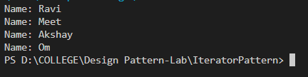

**Class Diagram:**

